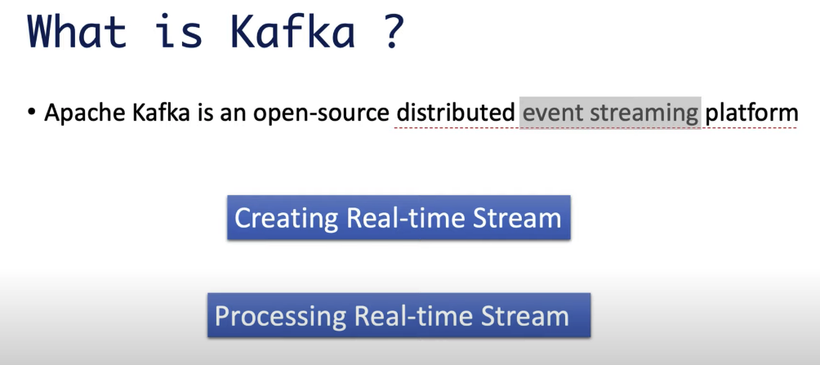

Thousands of users perform paytm transactions which is real-time stream of data

Paytm client calculates each user not exceeding 10 transactions per day and processes this stream of data.

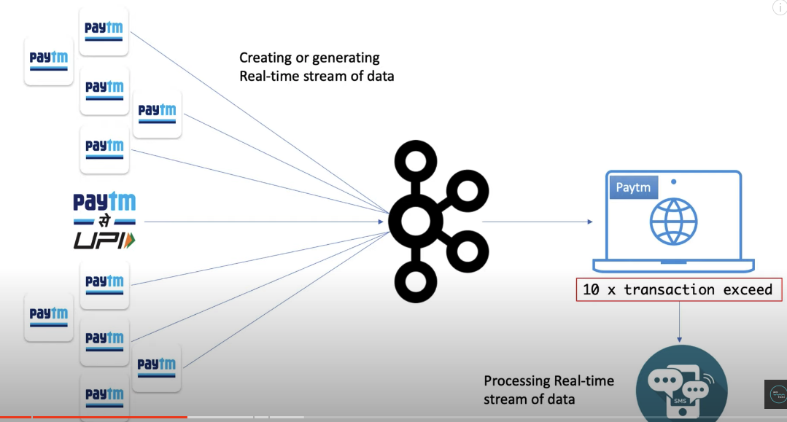

Even kafka servers are also distributed. Even if one server in one reason goes down, the other servers from other reasons handle traffic and avoid application down time as shown below.

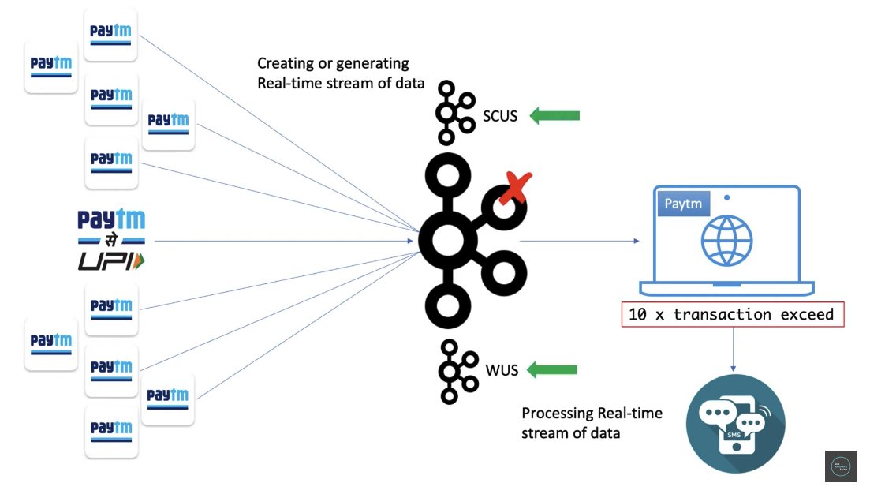

Imagine when a postman delivers post letter and he could not find the resident.

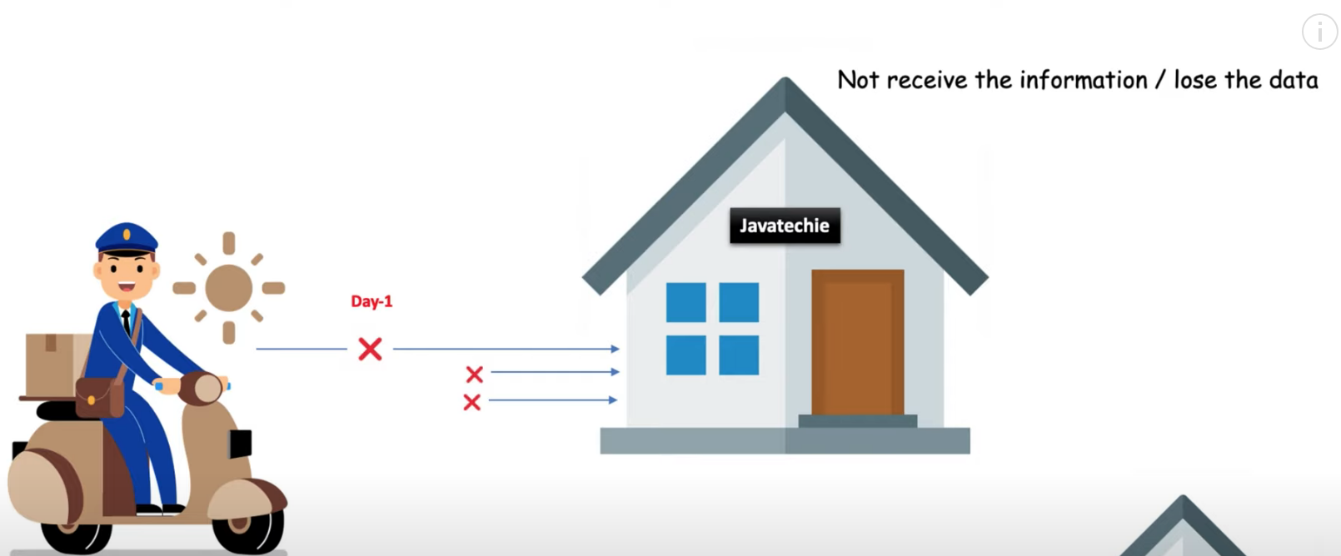

Imagine when a resident placed a letter box. Similarly kafka works.

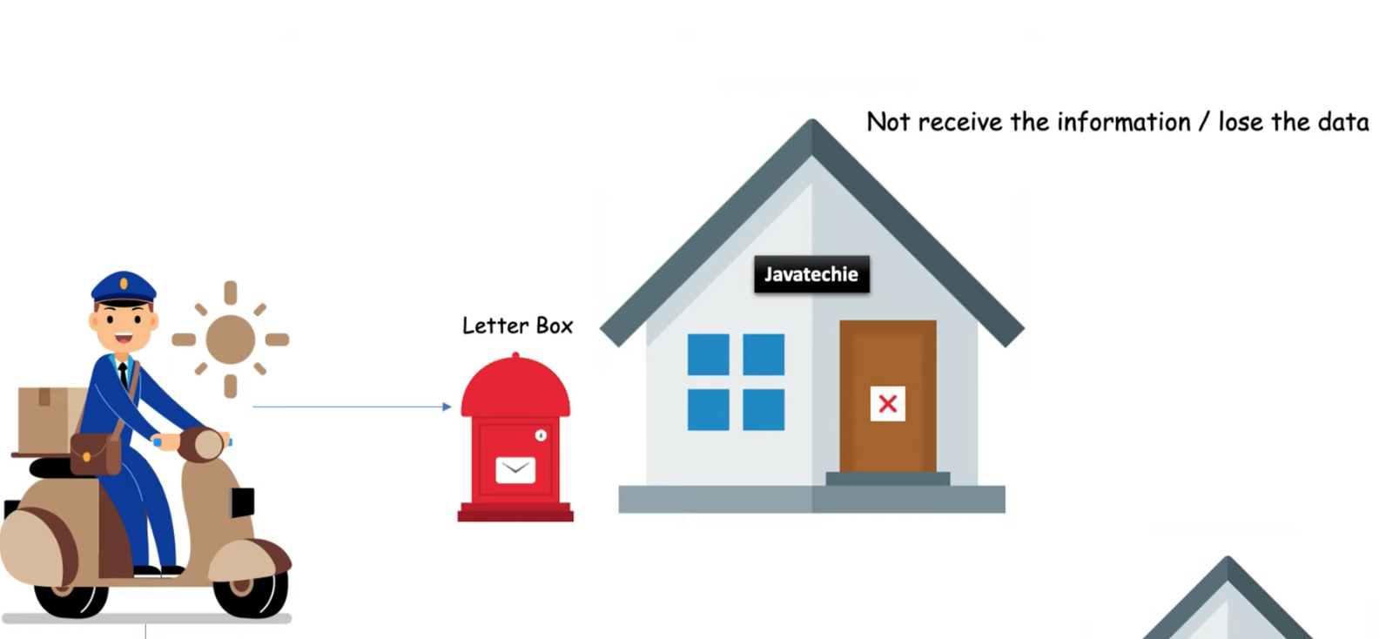

Similarly when application 1 wants to send a message to application2.

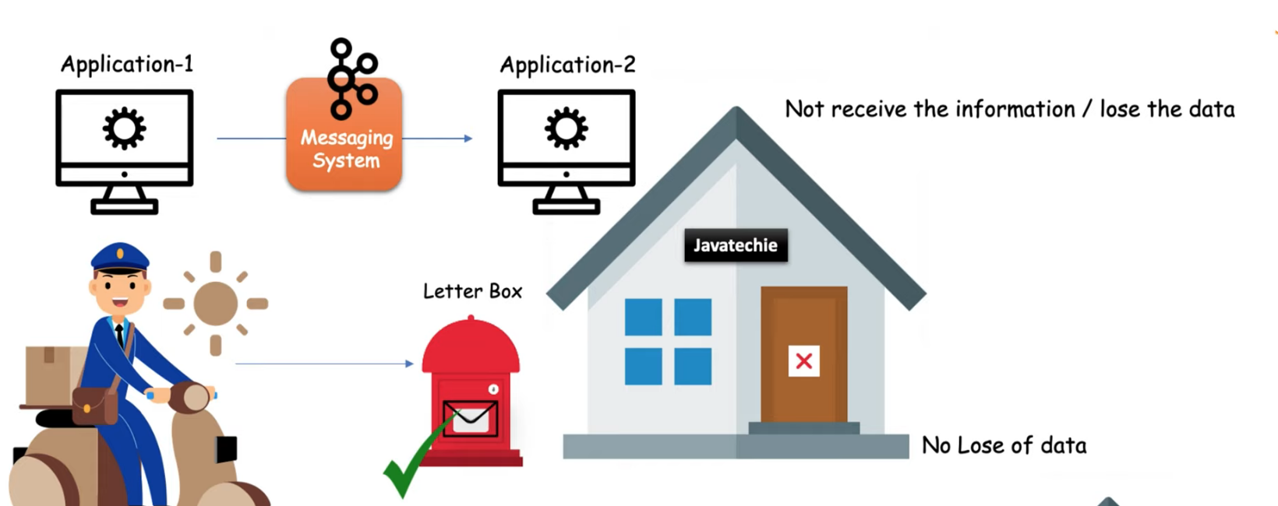

To maintain 9 applications we need to maintain 20 connections.

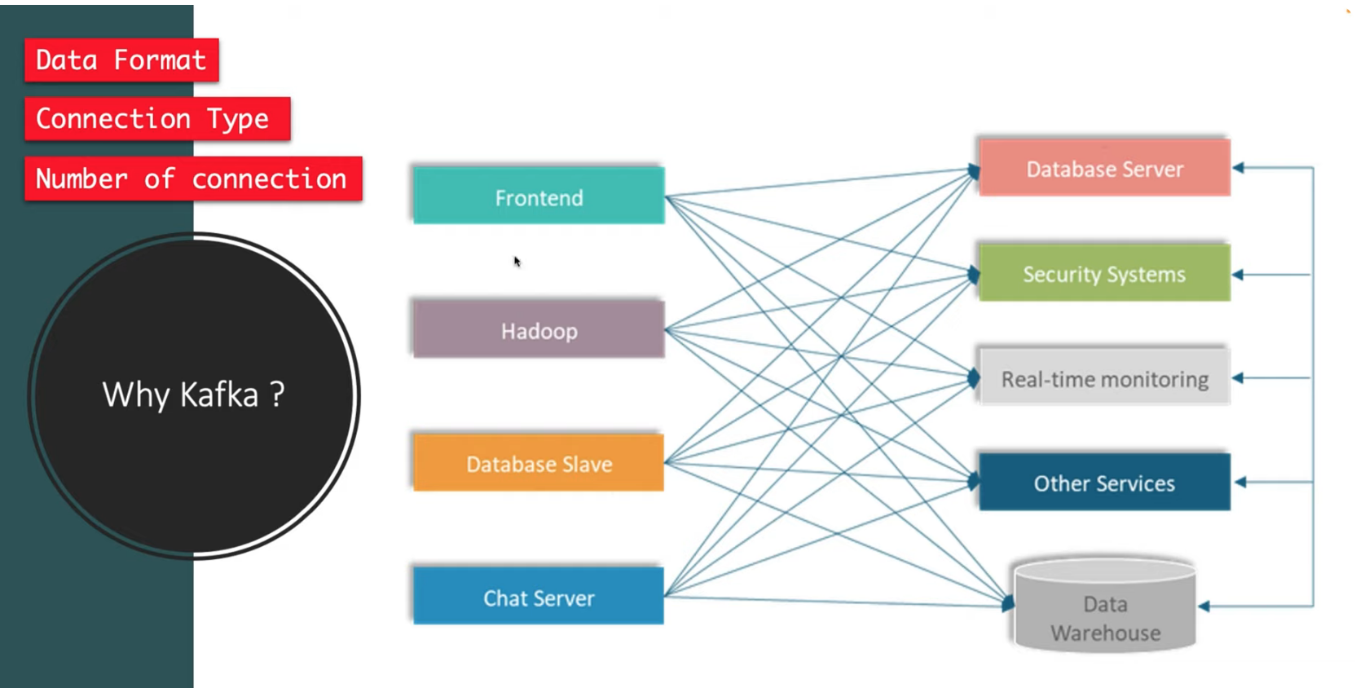

Here we have only 9 connections when we use kafka.

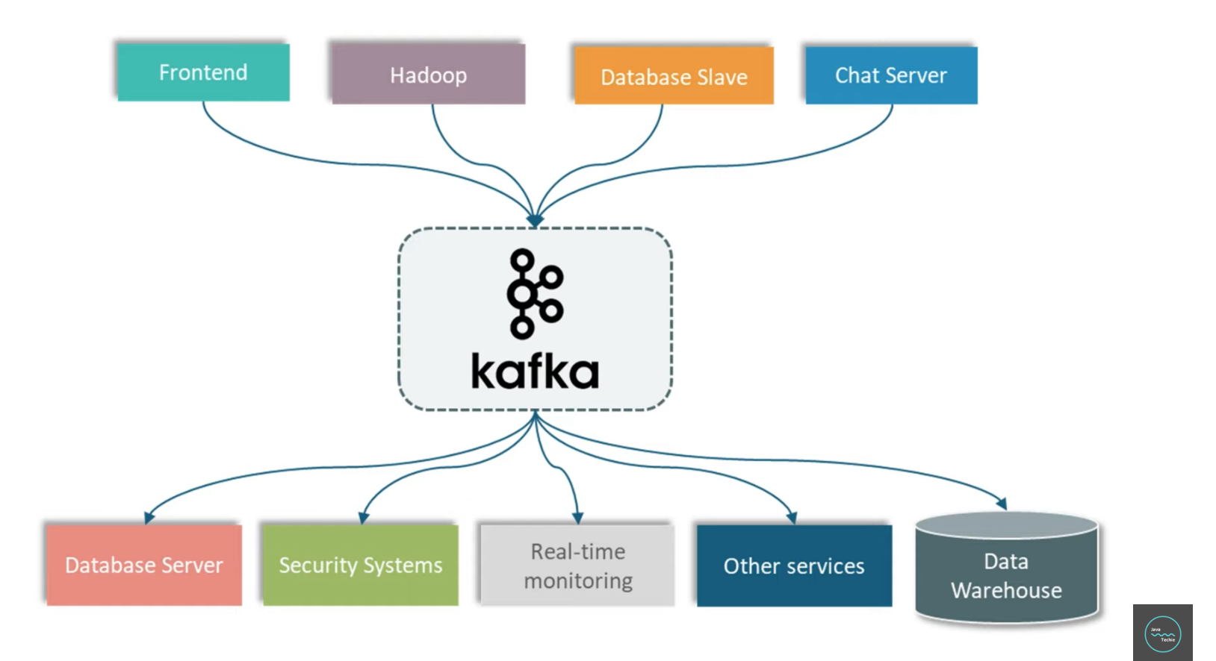

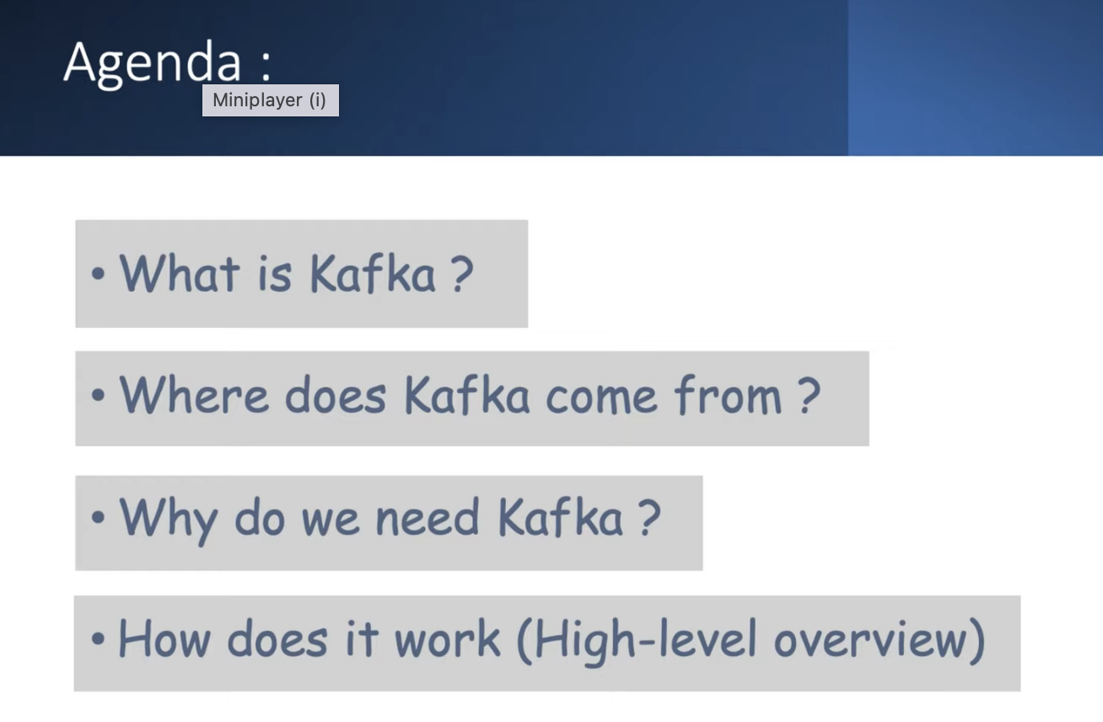

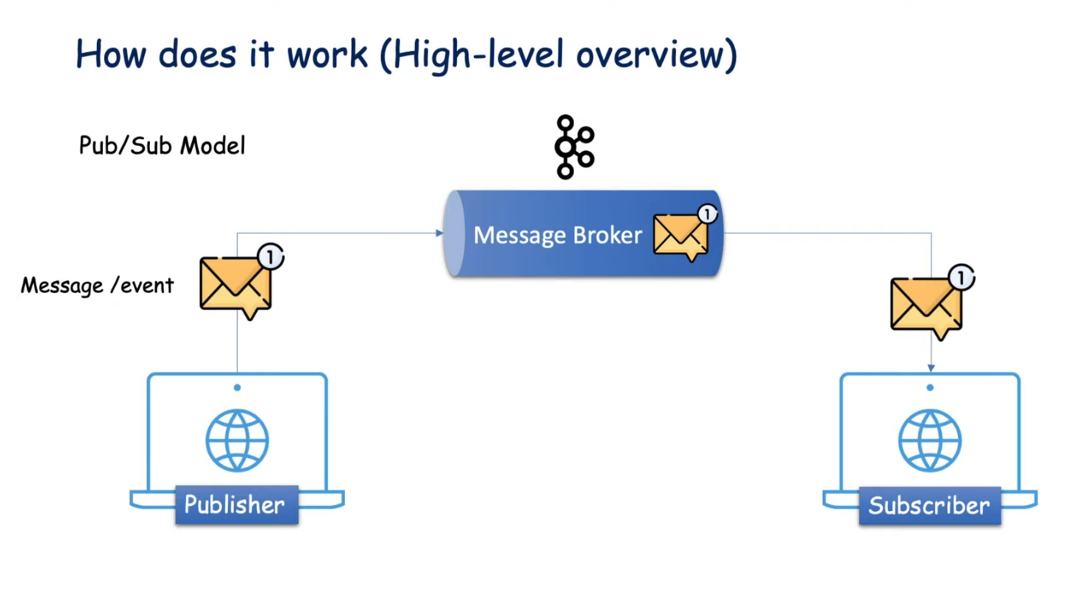

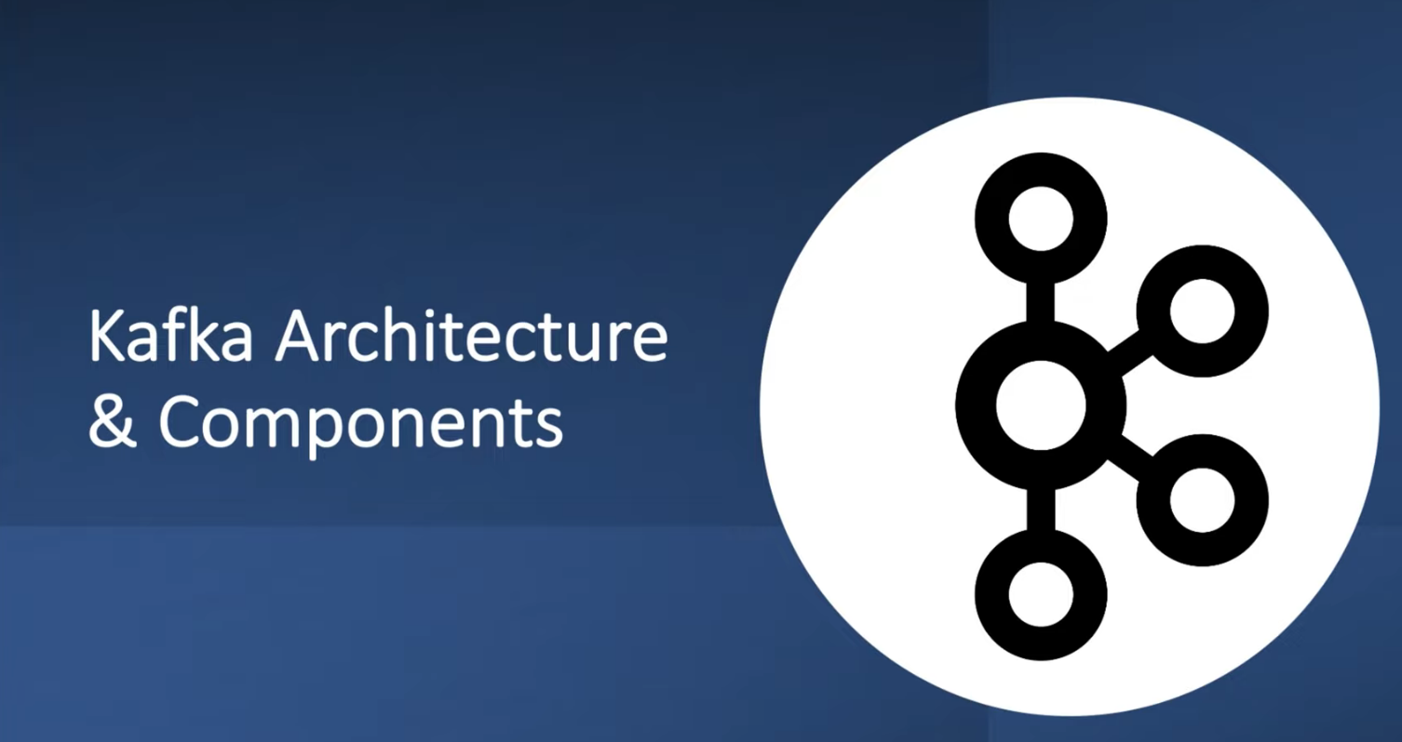

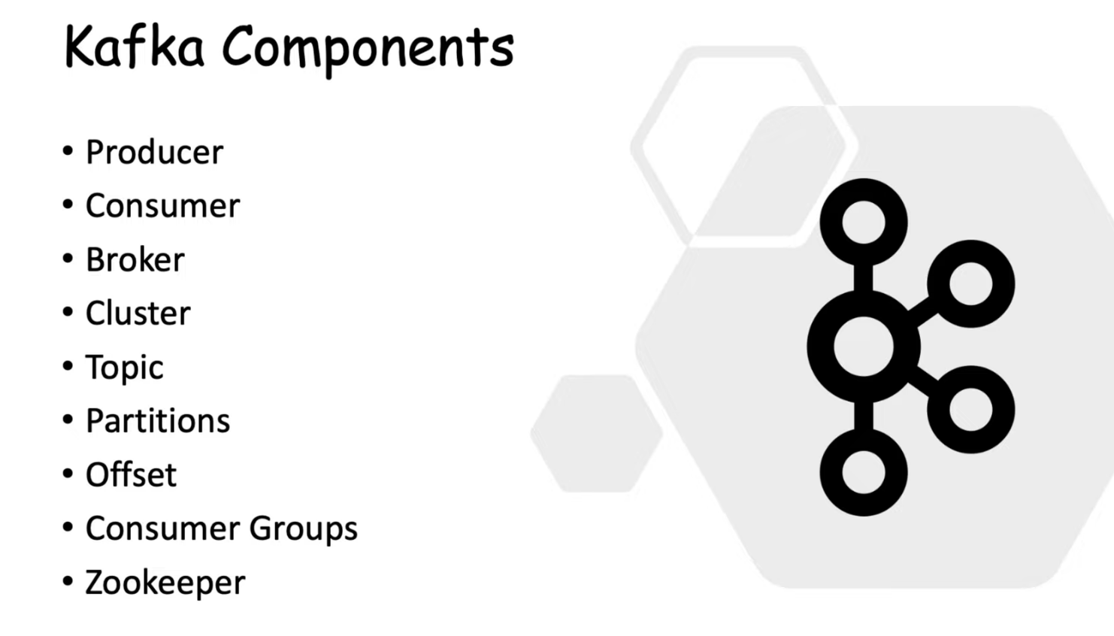

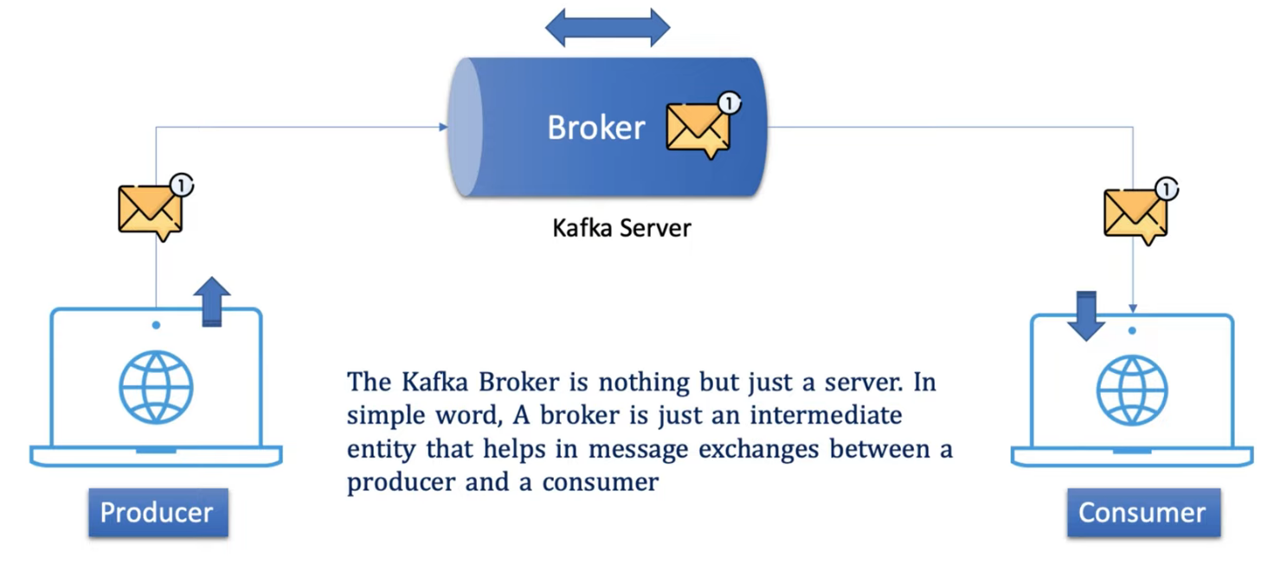

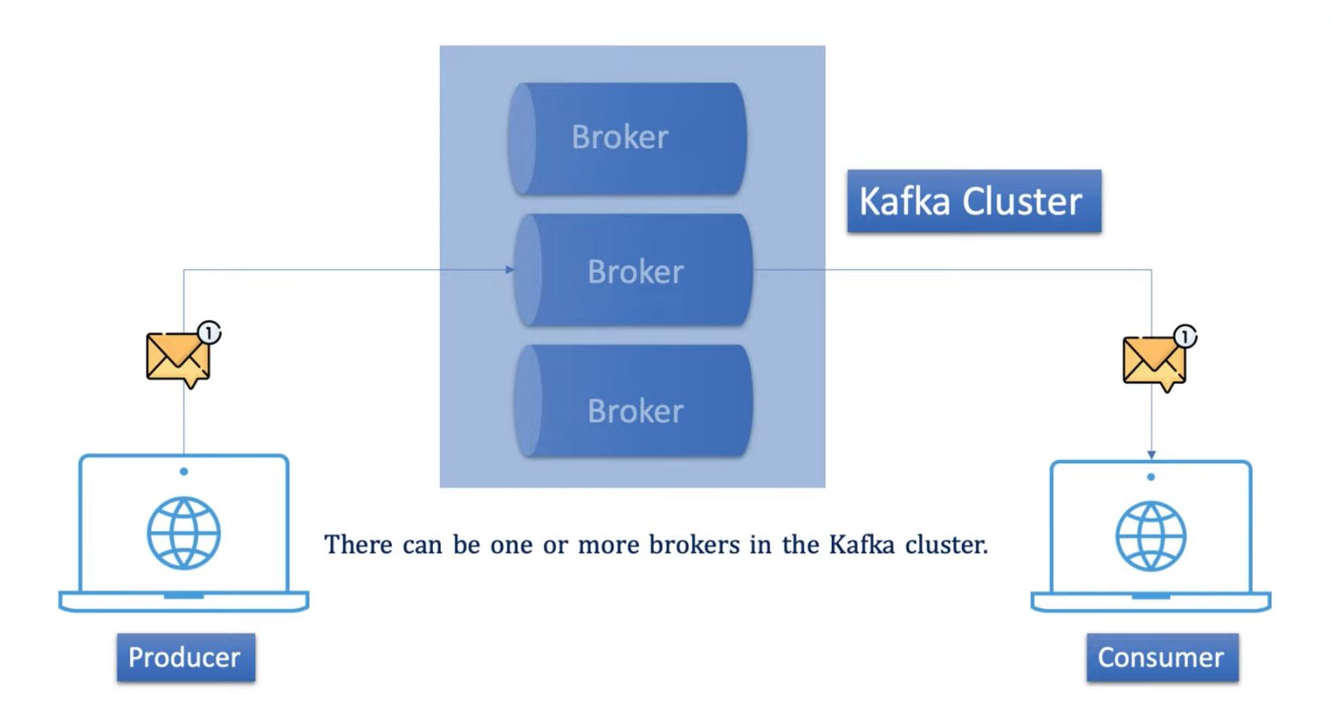

Need of topic: Topic categories different type of messages

So there is the upi payment topic, card payment topic and Insurance Payment topic.

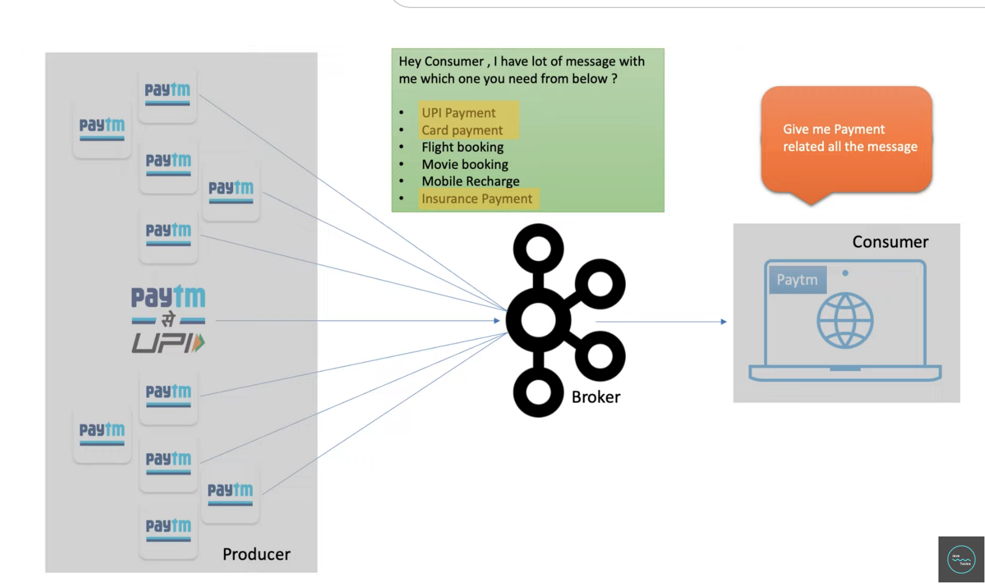

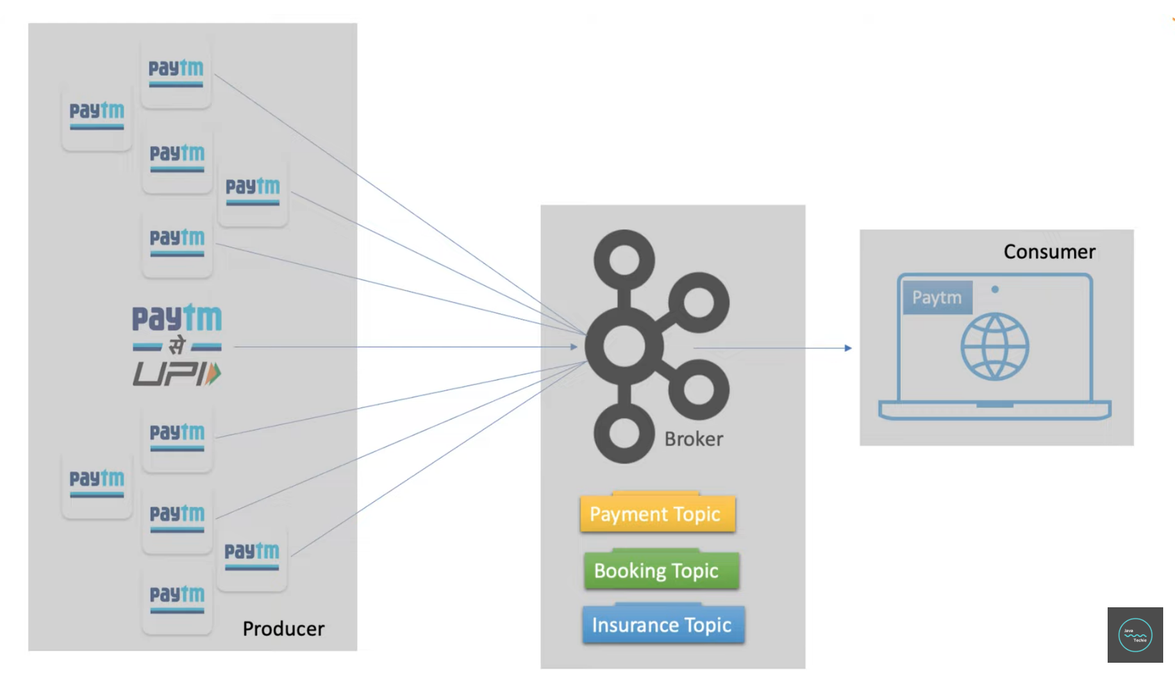

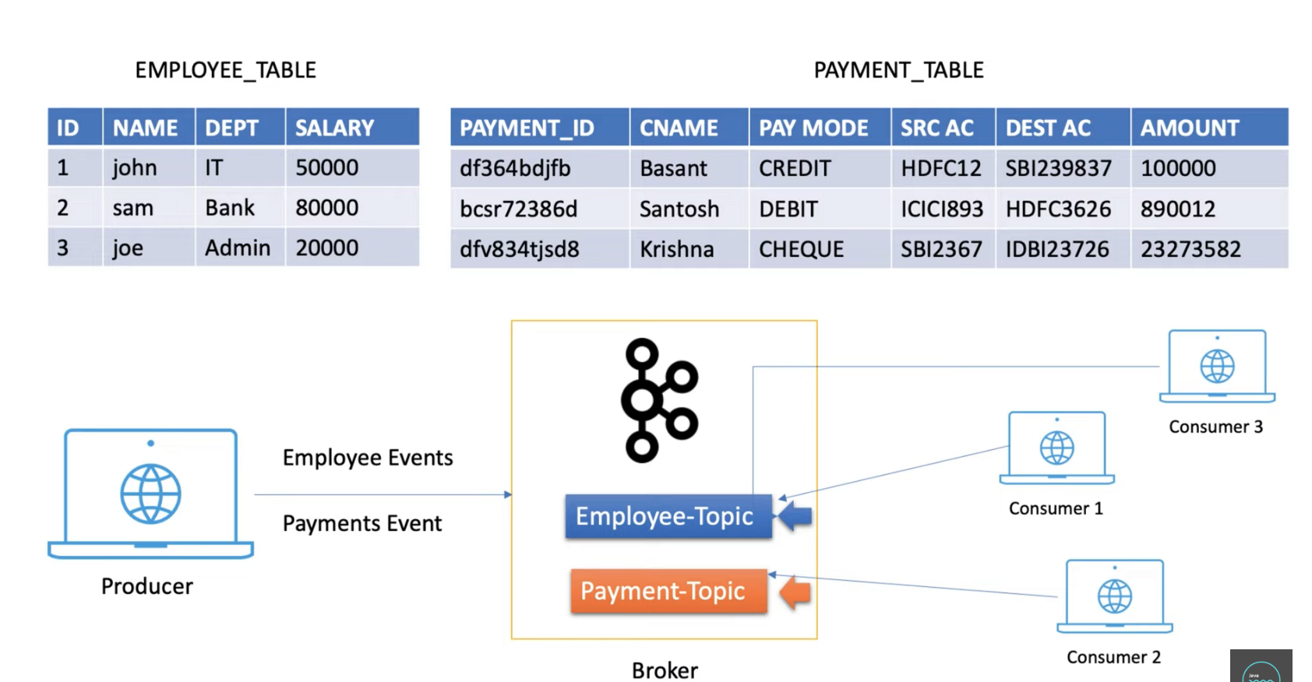

Topic definition

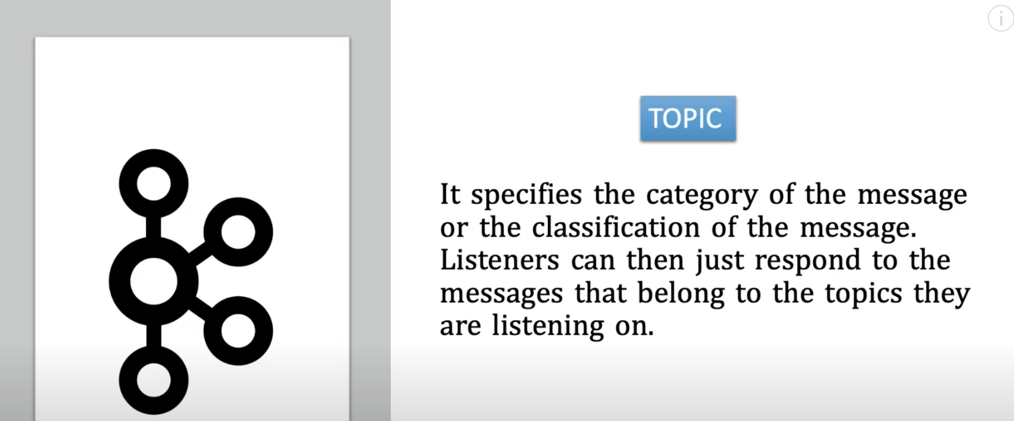

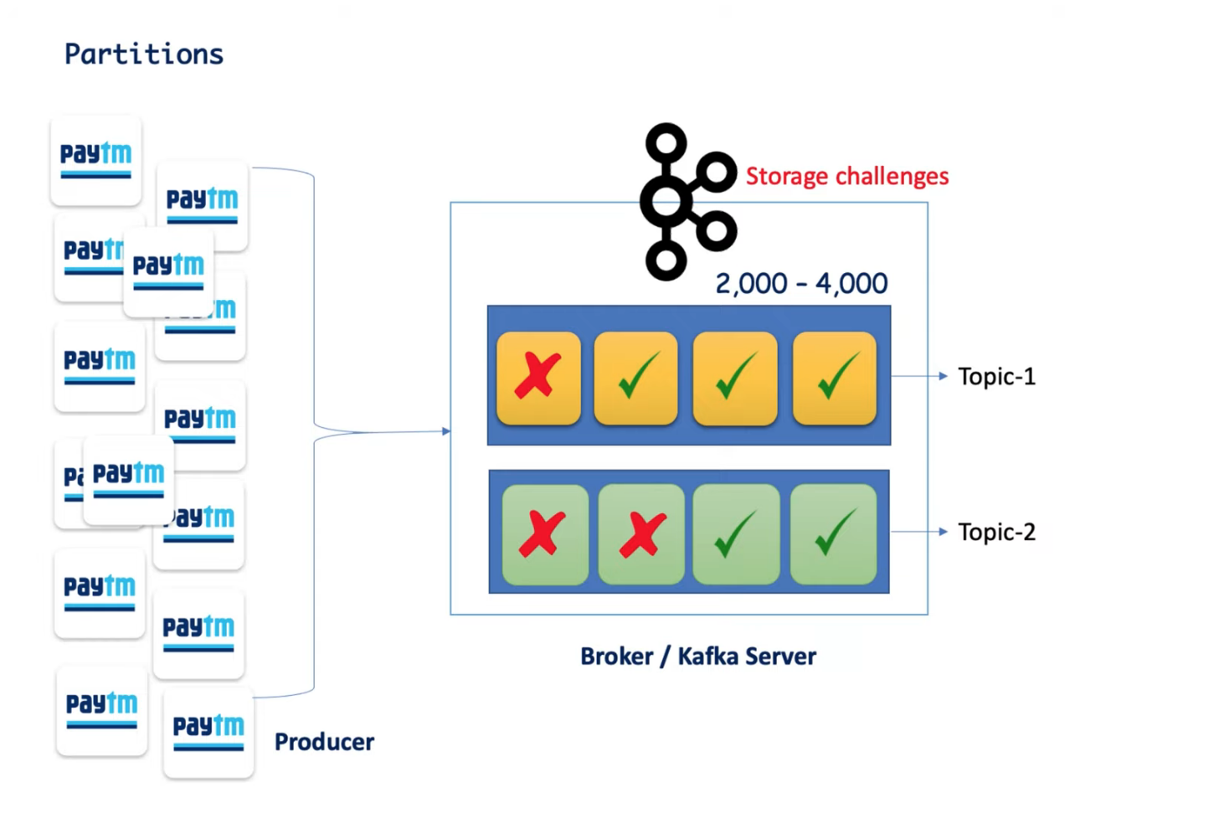

Each topic contains partitions - which concurrently receive messages.

Offset :

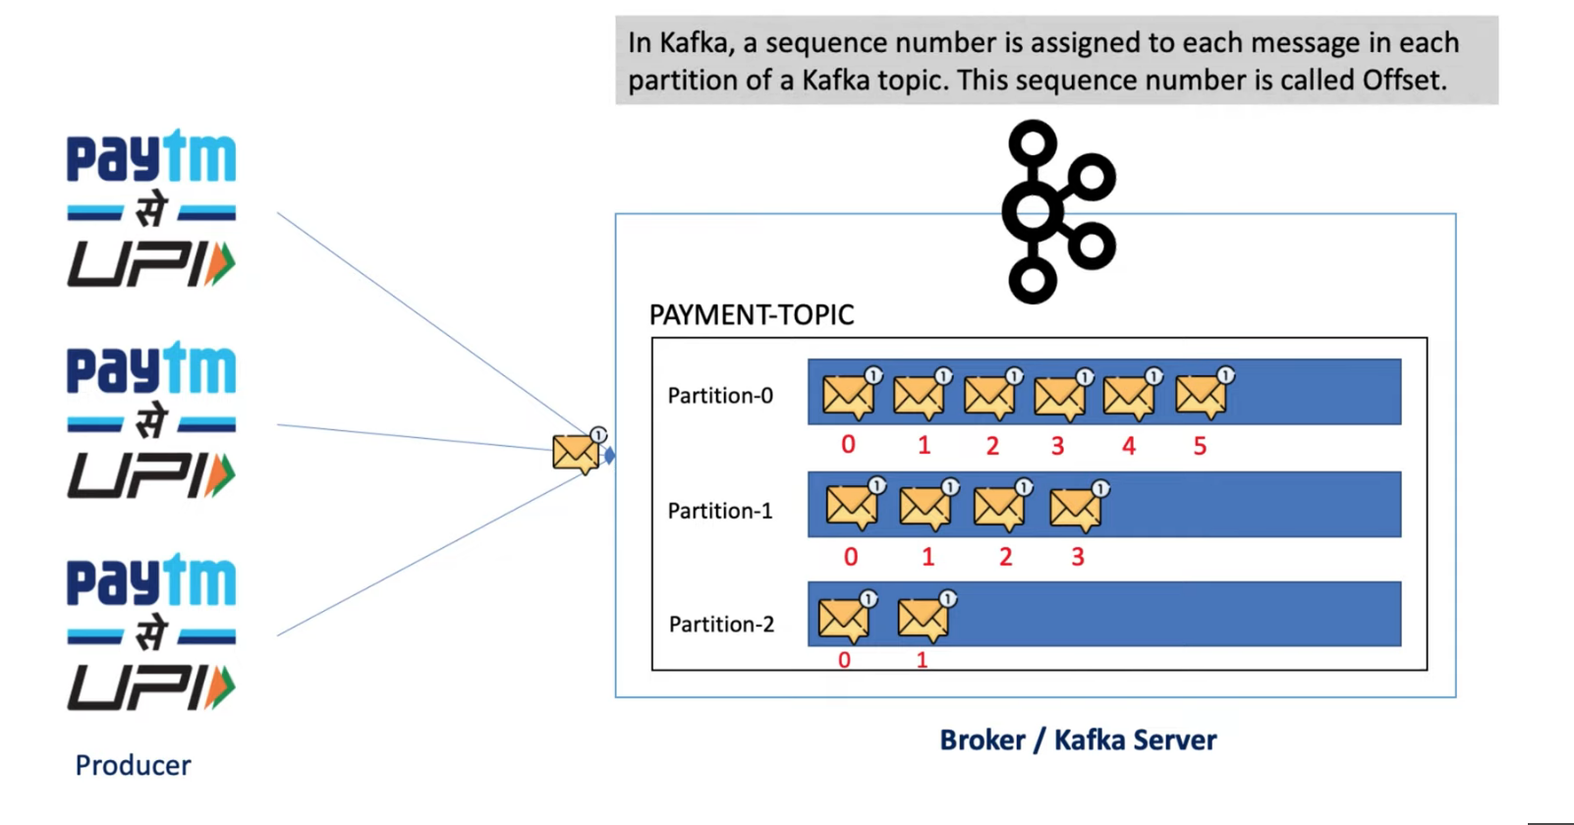

**Need of Consumer group:**

We have single consumer which reads all the partitions messages leads to performance issue because of no concurrency,

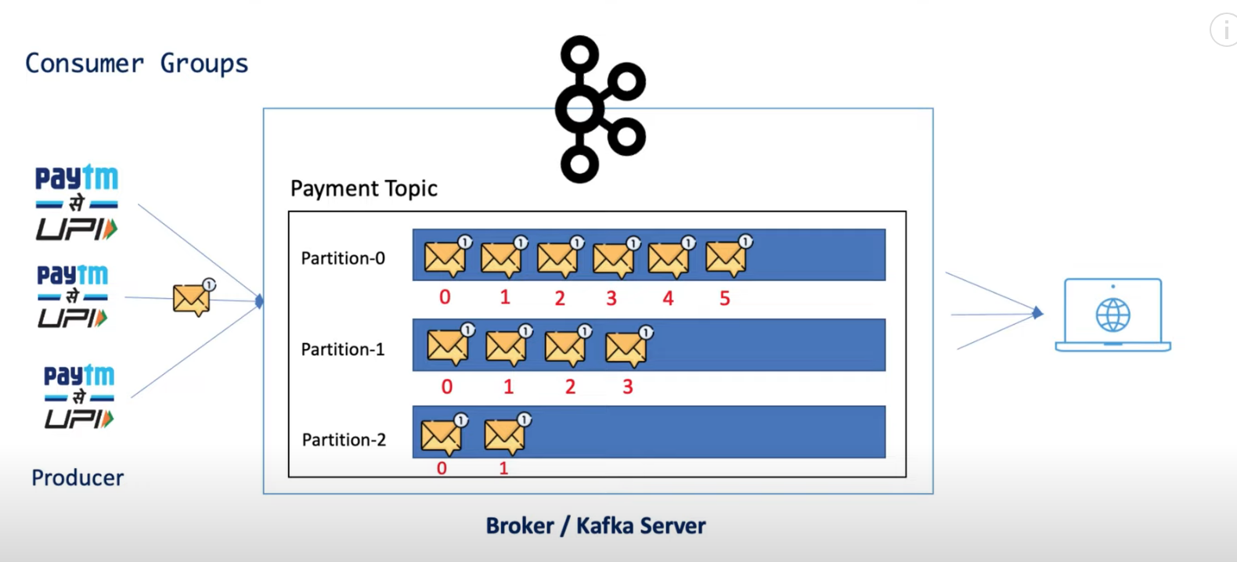

Each consumer polling time makes to consume data as soon as possible

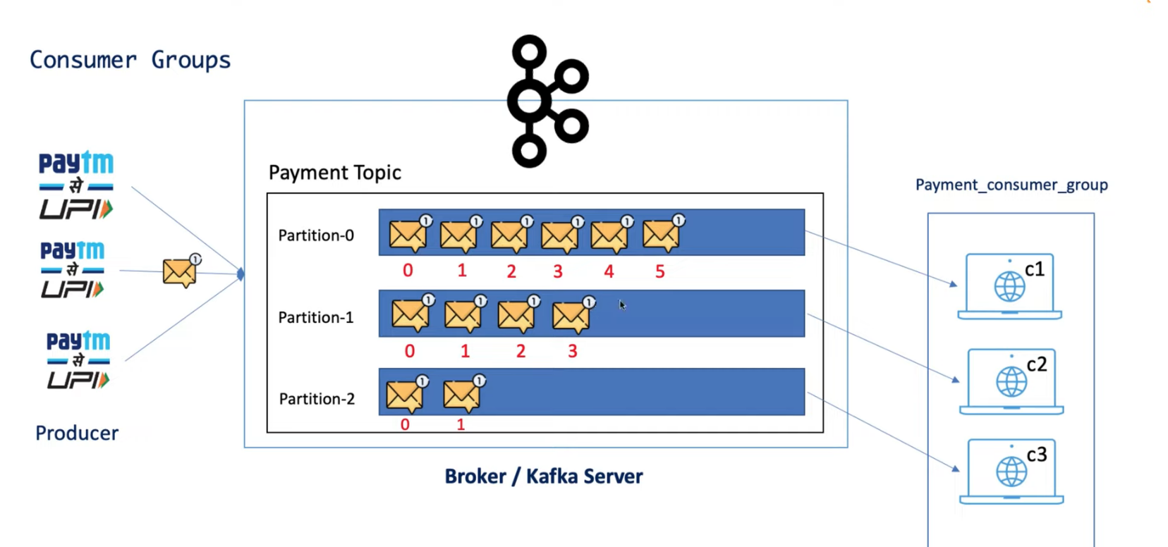

c1, c2 and c3 are instances of same consumer application.

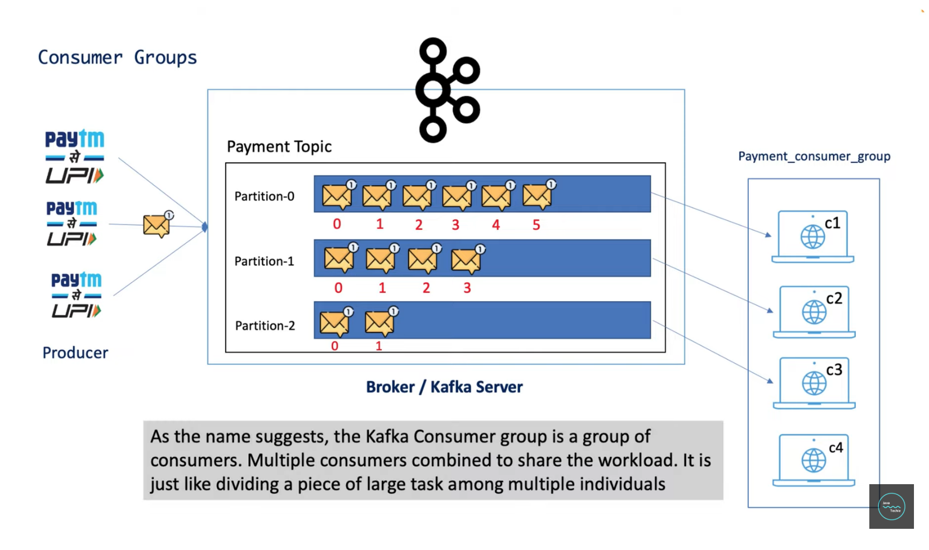

Consumer 4 sits idle. if only any working consumer goes down it will get a chance to work. This is called consumer rebalancing.

Zookeeper act as a manger of our entire Kakfa components

